What is a Digital SWOT Analysis?
A Digital SWOT Analysis is a strategic planning tool used to evaluate how well a business is using digital technologies, digital channels, data, and online customer experiences.
It is an adaptation of the traditional SWOT analysis, but the focus is specifically on the organisation's digital business environment.
SWOT stands for:
Area | Meaning | Digital Focus
S – Strengths | Internal advantages | What the business does well digitally
W – Weaknesses | Internal limitations | Where the business's digital capabilities are lacking
O – Opportunities | External possibilities | New digital trends, technologies or markets the business can exploit
T – Threats | External risks | Digital competitors, cybersecurity, changing technology, etc.
Simple way to remember it
Strengths & Weaknesses = Internal
Opportunities & Threats = External

Example: Digital SWOT for a Restaurant
Imagine a small restaurant called ABC Café that wants to improve its digital business strategy.
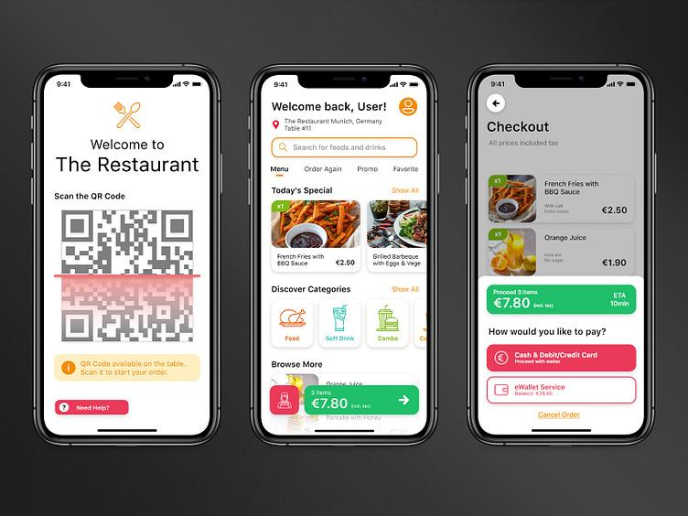
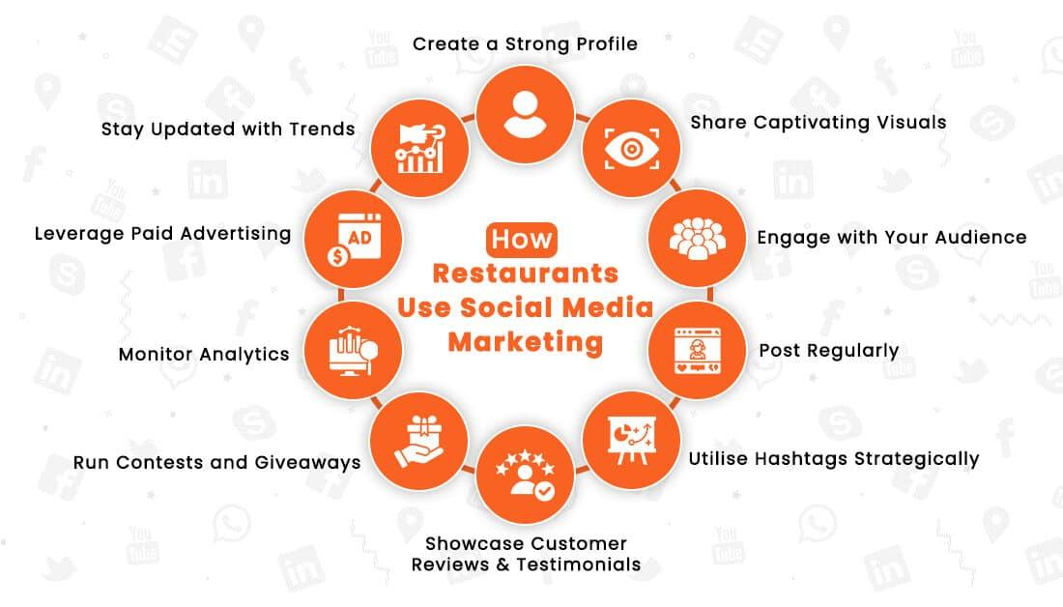
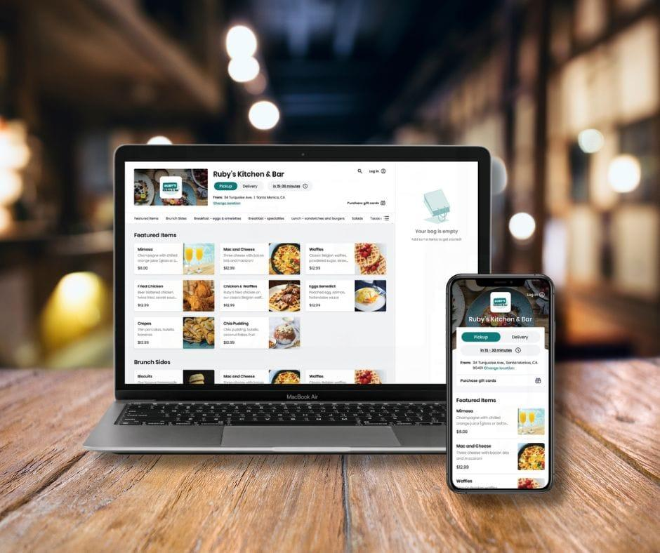

Digital SWOT Analysis
Strengths | Weaknesses
Has an active Instagram and Facebook presence | No dedicated mobile app
Customers can order through an online platform | Website is outdated
Accepts digital payments | Limited use of customer data
Has many positive online reviews | Staff have limited digital skills
Uses food-delivery platforms | Relies heavily on third-party delivery platforms

Opportunities | Threats
Develop a customer loyalty programme | Strong competition from food-delivery apps
Use AI to recommend menu items | Negative online reviews can spread quickly
Use social media influencers to promote the restaurant | Cybersecurity and payment fraud
Introduce online ordering through its own website | Competitors may offer better digital experiences
Analyse customer data to personalise promotions | Changes in social-media algorithms can reduce reach

Let's look at one item in more detail
Suppose ABC Café discovers that many customers are ordering through third-party delivery platforms.
This could be analysed as:
Strength:
The restaurant already has access to a large online customer base.
Weakness:
It has little direct access to customer data and must pay platform commissions.
Opportunity:
Create its own online ordering and loyalty system to encourage customers to order directly.
Threat:
A competing restaurant could offer faster delivery, better promotions or a more convenient app.
This demonstrates an important point:
Digital SWOT is not simply about listing technologies. It is about understanding how digital capabilities affect the organisation's competitive position.

Example: Digital SWOT for a College/School
For a more education-related example, consider a private college.
Strengths
- Uses an online learning management system.
- Students can access learning materials online.
- School has an active social-media presence.
- Online application and enquiry forms are available.
- Uses digital communication with students.
Weaknesses
- Some administrative processes are still paper-based.
- Website information is not updated regularly.
- Limited use of student data analytics.
- Staff have different levels of digital competency.
- No integrated student mobile application.
Opportunities
- Introduce AI-powered student support.
- Develop online short courses.
- Use digital marketing to reach international students.
- Introduce a mobile student portal.
- Use analytics to identify students who may need academic support.
Threats
- Competitors offering fully online programmes.
- Cybersecurity and data-privacy risks.
- Rapid changes in AI and educational technology.
- Negative social-media reviews.
- Increasing expectations for digital student services.

Digital SWOT vs Traditional SWOT
The main difference is the focus.
Traditional SWOT:
"What are the overall strengths, weaknesses, opportunities and threats facing our business?"
Digital SWOT:
"What are our strengths, weaknesses, opportunities and threats specifically in relation to digital technology, digital customers, digital channels and digital competition?"

